Planning and Design Document for BudgetEase

**1. Introduction**

Managing personal finances can be overwhelming and also time consuming but with our app BudgetEase it will be much easier. It is designed to simplify the whole process through automation, collaboration and AI-driven insights. Based on research findings from the apps we selected Vault22, Goodbudget and Spendee, BudgetEase aims to combine their best features while addressing their disadvantages. The goal is to create a financially empowering, gamified experience that encourages our users to track expenses, set goals and improve financial literacy intuitively.

The purpose of this document is to provide a structured plan for the development of BudgetEase ensuring that it is superior to existing apps. This design phase ensures a clear roadmap for implementation which will help minimize development challenges.

Why BudgetEase Stands Out

* AI-powered budgeting insights for automated financial guidance.
* Gamification elements to increase engagement and discipline.
* Offline first function with optional cloud backup.
* Multi-currency support for international users.
* Secure encryption & privacy first approach.

**2. App Overview**

**App Name**: BudgetEase

Tagline: “Your Budget Made Easy”

**Initial Icon Design**

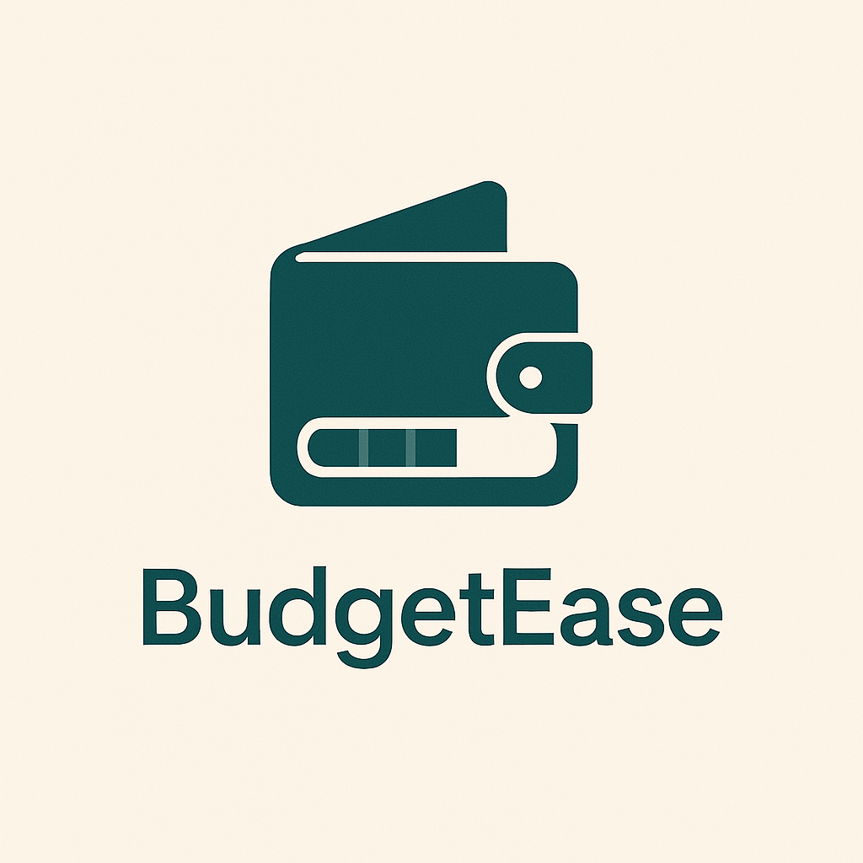

* A modern wallet icon with a progress bar overlay which symbolizes financial growth and tracking.

**Key Features & Competitive Advantages**

1. **AI-Powered Insights** – Detects spending patterns of our users and offers smart financial suggestions (e.g., alerts for overspending, reminders for savings goals).
2. **Gamification & Rewards** – Implementing Vault22’s Financial Fitness system with budgeting streaks, achievement badges and also no spend challenges.
3. **Envelope Budgeting System** – Borrowing Goodbudget’s method to help users allocate funds into custom virtual envelopes for disciplined spending.
4. **Multi-Currency Support** – Offline currency conversion for users managing multiple accounts or traveling internationally.
5. **Collaborative Budgeting** – Inspired by Spendee’s shared wallets allowing families, couples or roommates to manage budgets together.
6. **Advanced Visual Insights** – Combining Spendee’s interactive charts with customizable financial reports for a more in depth analysis.
7. **Offline-First Approach** – Unlike competitors that rely heavily on cloud storage, our app BudgetEase ensures full offline functionality with RoomDB syncing to Firebase for optional cloud backup.
8. **Secure & Private** – AES-256 encryption ensures user data is protected and no forced cloud sync prevents unnecessary data sharing.

**3. Detailed List of Requirements**

Core Features

1. **User Authentication**
   1. **Firebase Authentication** for secure login/registration.
   2. **Biometric authentication** (fingerprint/face recognition) as an optional setting.
   3. **Two-Factor Authentication (2FA)** for added security.
2. **Expense Tracking**
   1. Users can manually enter transactions (**A**mount, Date, Category, Description, Receipt Upload).
   2. Editable and deletable entries.
   3. **AI-powered categorization** for auto-sorting expenses (future enhancement).
3. **Category Management**
   1. Users can create, edit, and delete categories.
   2. **Nested subcategories** for better tracking (e.g., *Groceries → Dairy, Snacks*).
4. **Budgeting Features**
   1. **Monthly spending limits** with category specific budgets.
   2. **Savings goal tracker** to monitor progress toward financial goals.
   3. **Realtime budget progress tracking** and alerts.
5. **Visual Reports & Analytics**
   1. **Pie charts for category based spending**.
   2. **Line charts showing daily spending trends**.
   3. **Export data as PDF/CSV** for offline storage.
6. **Expense List & Filtering**
   1. View and filter transactions by date range, category or amount.
   2. Receipt images accessible from the list.
7. **Gamification & AI Integration**
   1. Badges for consistency and financial discipline (*e.g., “No Spend Week,” “Saved R500”*).
   2. **AI-driven budgeting tips** (alerts when overspending, suggesting cutbacks).
   3. **Daily streaks & challenges** (*e.g., “Log Expenses 7 Days in a Row”*).
8. **Offline Storage with RoomDB**
   1. Ensuring full offline functionality for users who prefer local storage.
9. **Cloud Backup (Optional Expansion Feature)**
   1. Firebase Firestore for collaborative budgets and cloud sync.
10. **Security Measures**

* **AES-256 encryption** for sensitive user data.
* **GDPR compliance** (explicit consent for data sharing, privacy-first approach).

**4. User Interface Design & Navigation**

**Login & Registration Screen**

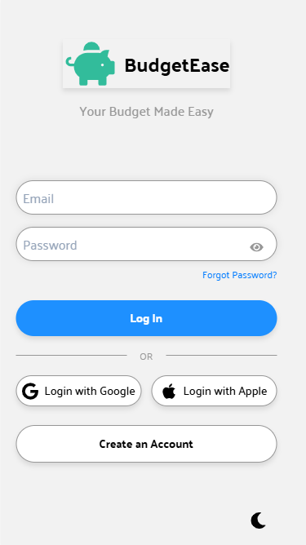

**Purpose:**

The Login and Registration screen serves as the entry point to BudgetEase. It ensures secure authentication and a smooth onboarding experience for new users.

**Key Functions:**

* **User Authentication** – Allows users to log in securely using email/password, social sign-in (Google/Apple) or biometric authentication.
* **Registration** – Enables new users to sign up by providing their details and setting up their accounts.
* **Password Recovery** – Includes a "Forgot Password" option for users who need to reset their credentials.
* **Dark Mode Toggle** – Provides users the ability to switch between light and dark themes.

**Home Dashboard Screen**

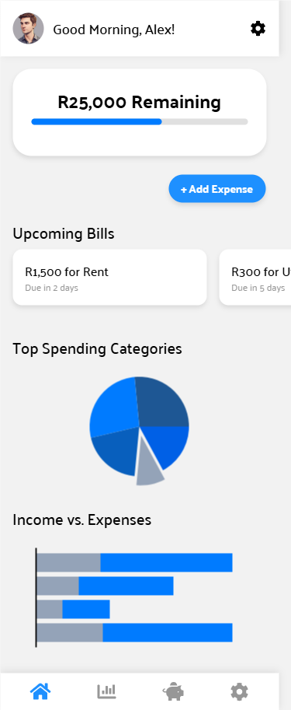

**Purpose:**

The Home Dashboard screen provides an at a glance overview of the user’s financial status displaying essential information and quick access features.

**Key Functions:**

* **Current Balance Display** – Shows the user’s total balance and remaining budget.
* **Quick Expense Entry** – Includes a floating "+ Add Expense" button for fast transaction logging.
* **Upcoming Bills** – Displays a scrollable list of bills due soon helping users manage deadlines.
* **Spending Overview** – Visual representations (graphs, charts) of spending trends and category wise expenses.
* **Navigation Bar** – Provides quick access to Reports, Budget Goals and Settings.

**Add Expense Screen**

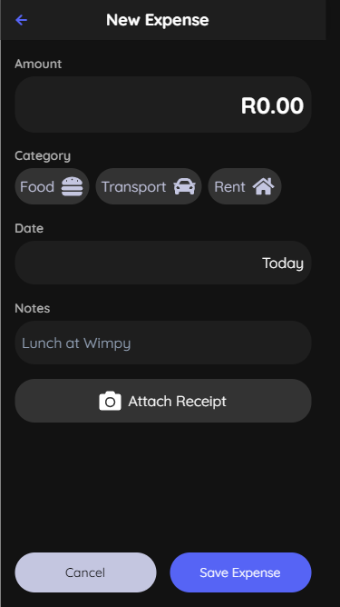

**Purpose:**

The Add Expense screen allows users to quickly log their daily expenses with essential details.

**Key Functions:**

* **Transaction Entry** – Users input the amount, category and date of an expense.
* **Category Selection** – Allows users to assign expenses to predefined categories (e.g., Food, Transport, Rent).
* **Notes & Receipts** – Users can add notes or attach receipt images for record keeping.
* **Quick Save & Edit** – Provides buttons for saving or modifying an expense entry.

**Budget Management Screen**

## 

**Purpose:**

The Budget Management screen enables users to **set, adjust, and track their spending limits** across different categories in a visually intuitive manner.

**Key Functions:**

* **User Greeting & Quick Action -** Displays a personalized greeting (e.g., *"Good Morning, Alex!"*). A prominent **"**Set New Budget**"** button, allowing users to adjust overall spending limits with ease.
* **Budget Overview -** A pie chart visualization showing budget distribution across different categories.
* **Budget Usage Indicator -** Displays percentage of total budget used (e.g., *"Budget Used: 65%"*).
* **Total & Remaining Budget -** Clear text labels indicating total allocated budget (e.g., *R10,000*) and remaining balance (e.g., *R3,500*).
* **Category-Based Budget Tracking -** Budget Allocation Cards for key spending categories such as:
  + - Groceries: Allocated R2,500, spent R1,800 (with a progress bar).
    - Entertainment: Allocated R1,500, spent R1,275.
    - Utilities: Allocated R500, overspent R600 (highlighted in red).

**Analytics & Reports Screen**

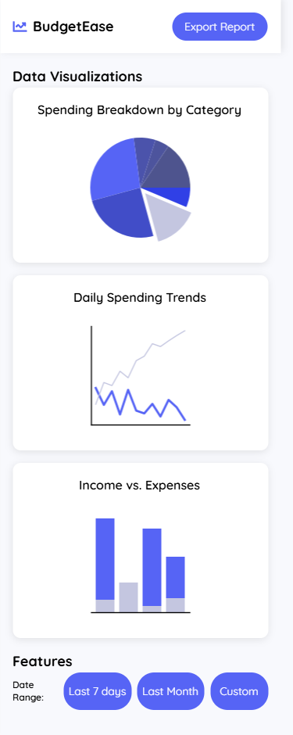

**Purpose:**

The Analytics & Reports screen provides users with insights into their spending habits through data visualization.

**Key Functions:**

* **Export Feature -** A prominent "Export Report" button for users to download reports in PDF or CSV format.
* **Spending Breakdown by Category -** A pie chart displaying expenses per category.
* **Daily Spending Trends -** A line graph showing spending patterns over time.
* **Income vs. Expenses -** A bar chart comparing income against expenses.
* **Date Range Selector -** Users can choose between "Last 7 days", "Last Month" or "Custom" date ranges.

**User navigation:**

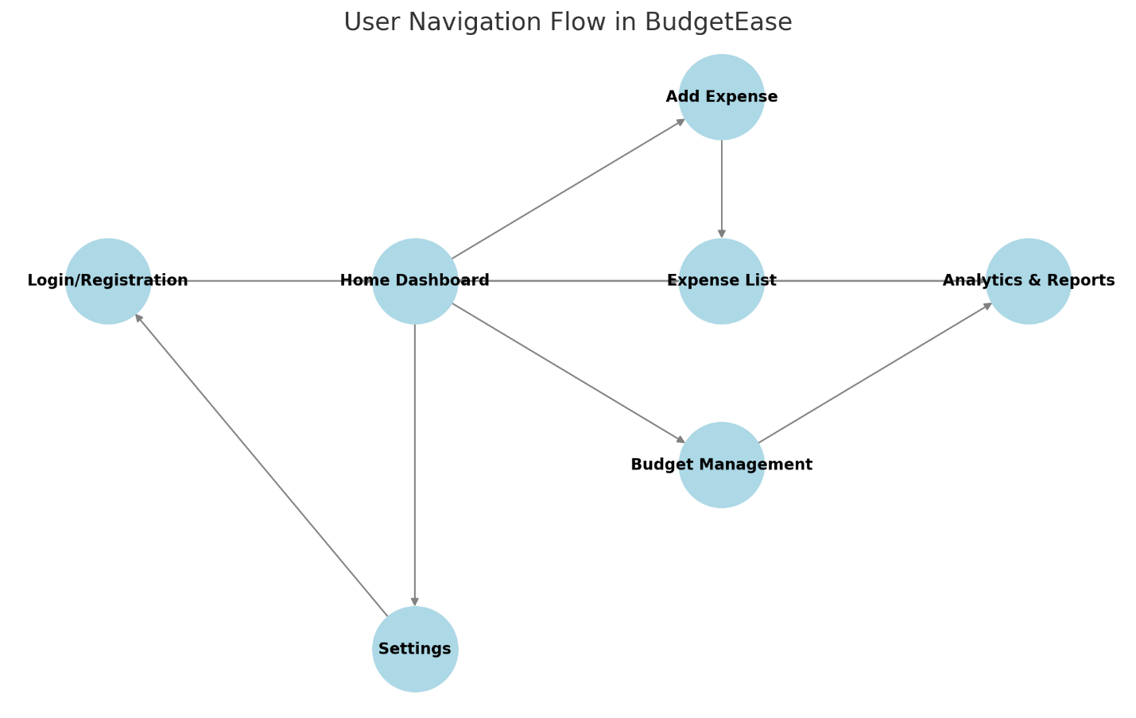

**5. Project Plan (Gantt Chart)**

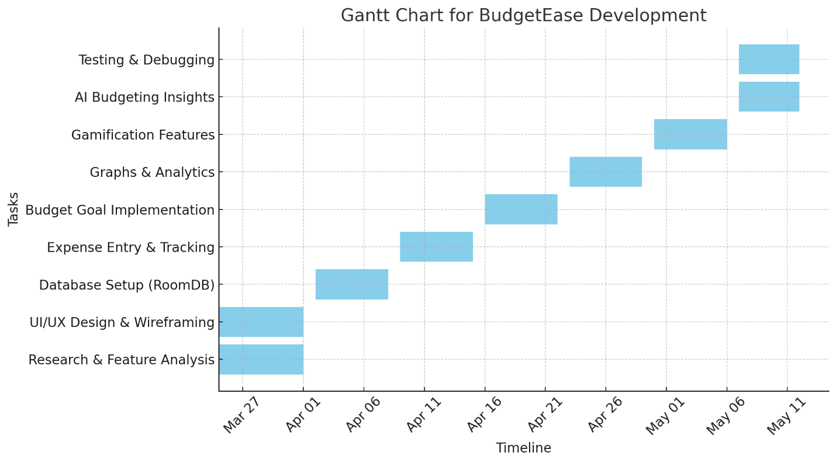

**6. Conclusion**

BudgetEase is designed to be a superior, easy and intuitive budgeting too**l** by combining **a**utomation, AI-driven insights, gamification and also strong security. By addressing the weaknesses of Vault22, Goodbudget, and Spendee, BudgetEase creates a financially empowering easy to use solution that is also feasible for development.

## References

Goodbudget, G. (2023) *Home*, *Goodbudget*. Available at: <https://goodbudget.com/> (Accessed: 27 March 2025).

vault22, vault22 (2025) *VAULT22 South Africa*, *Vault22 South Africa*. Available at: <https://www.vault22.io/za> (Accessed: 26 March 2025).

S. a.s. (2025) *Money manager & budget planner*, *Spendee*. Available at: <https://www.spendee.com/> (Accessed: 28 March 2025).